OH4VNA Emulator Report

prepared by:
Reza Farsi

Reviewed by:

01.12.2025

Folders
Table 1. The folder contents description
Datasheet info | Folder (.txt) | Digitized S-parameters of the coupler extracted from the datasheet plots
Sprams MACP-011045 | Folder (.s4p) | Raw measured S-parameter files of the couplers provided by the manufacturer
Sprams MACP-011045_corrected | Folder (.s4p) | Port-swapped S-parameter files of the couplers
dut_gamma_arrays | .csv | AI-generated DUT gamma array
MACP-011045-Sparam-corrected | .pptx | S-parameter plots of the couplers and the OH4VNA emulator schematic
OH4VNA_emulator | .py | Python code for the OH4VNA emulator
S21_VNA_DUT1-6 | .png | Expected S-parameter plots for DUTs 1–6
Swap_Sparam_Nport_XtoY | .py | Python script for port swapping in an N-port S-parameter network
vna_s21_DUT1-6 | .csv | Expected S-parameter data for DUTs 1–6

The Coupler
The coupler used for this emulator is the MACP-011045. The S-parameters of the device were measured and provided by MACOM for three different PCB-based models. The files were generated using scikit-rf 1.8.0, with the following port assignments (Port 1 → pin 1 (Input), Port 2 → pin 6 (Output), Port 3 → pin 4 (Isolated), Port 4 → pin 3 (Coupled)).
To match the manufacturer’s datasheet conventions and ensure compatibility of the S-parameter plots, ports 3 and 4 were swapped using the Python script “Swap_Sparam_Nport_XtoY.py”.
The S-parameter of the corrected files are plotted as below:
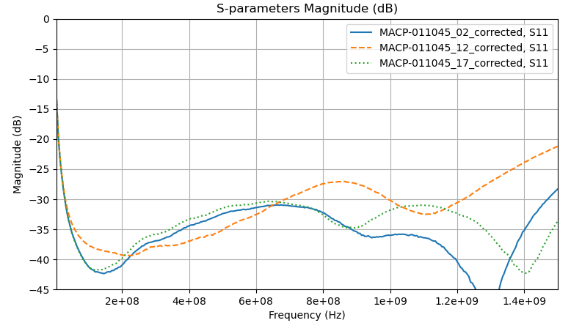
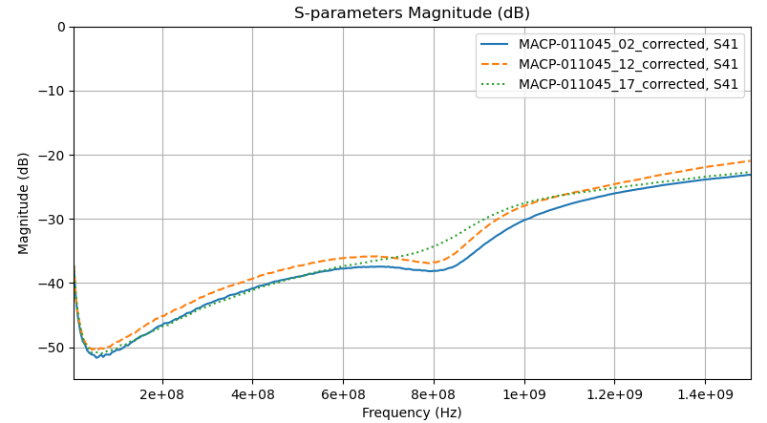
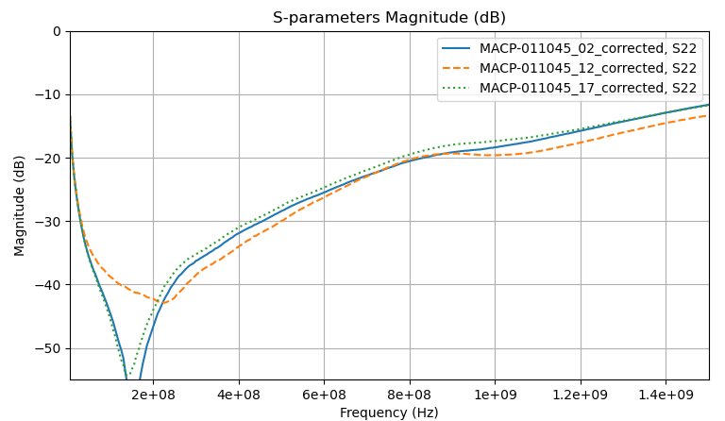
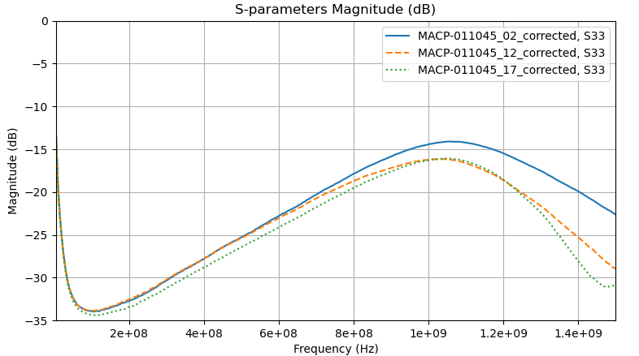
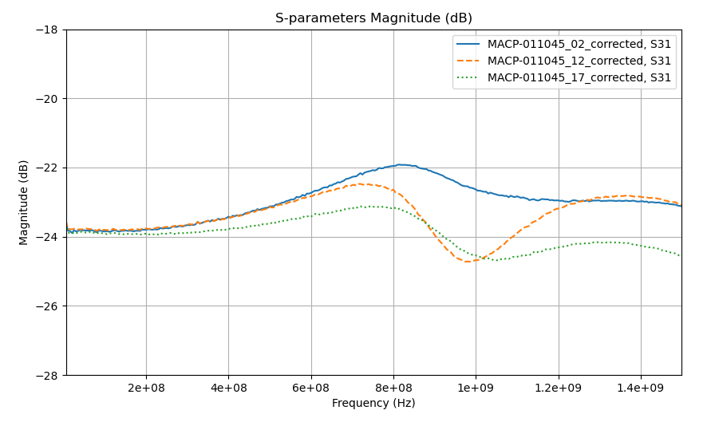
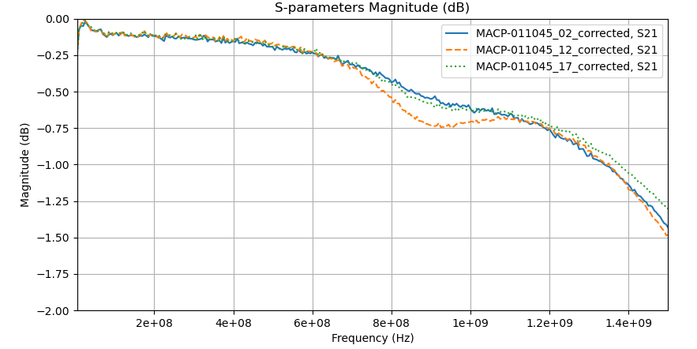

Figure 1: The S-parameter of the corrected files for the three different components

The OH4VNA Emulator
For designing the emulator, we assumed a downlink signal level of approximately –30 dB at the coupler input (Port 1) and an uplink gain of approximately 20 dB after the coupler’s coupled port.
The complete circuit diagram is shown below: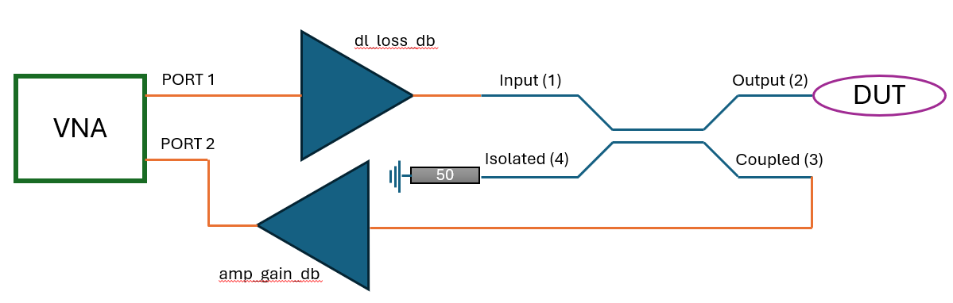
Figure 2: The complete diagram of the emulator circuit defined in python
The code defines an internal ideal coupler that is used whenever a valid measured .s4p file is not provided, or when a different coupling or directivity is required. It also defines six DUTs with the following characteristics:
- DUT 1 — Mild reflection (|Γ| = 0.5, phase = –60° × 2)
- DUT 2 — Strong reflection, inverted (|Γ| = 0.9, phase = +45° × 2)
- DUT 3 — Low reflection (|Γ| = 0.2, phase = 120° × 2)
- DUT 4 — Mild dispersion
- DUT 5 — Strong phase rotation
- DUT 6 — Weak reflection with long delay
The code also provides ideal Short, Open, and Load networks that can be connected to the output port of the coupler. In addition, a calibration switch is implemented, enabling the use of these ideal OSL standards to calibrate the DUTs.
Finally, the code generates plots of S21 of the VNA (P1 to P2) for both the ideal OSL standards and the DUTs. It also plots the calibrated and ideal S11 of each DUT when the calibration switch is ON, and the uncalibrated S11 when the calibration switch is OFF.
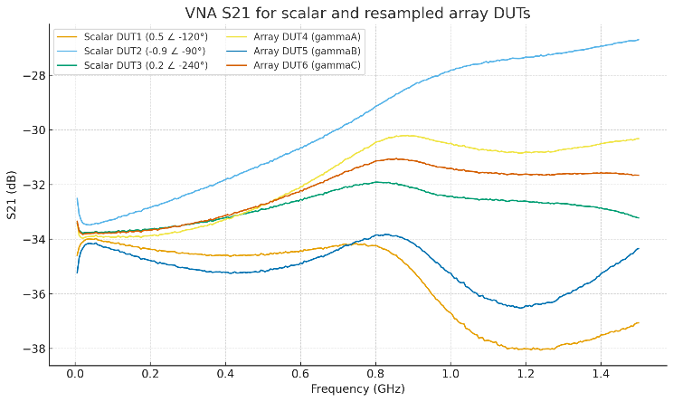
Figure 3. The expected S-parameter plot of the DUTs
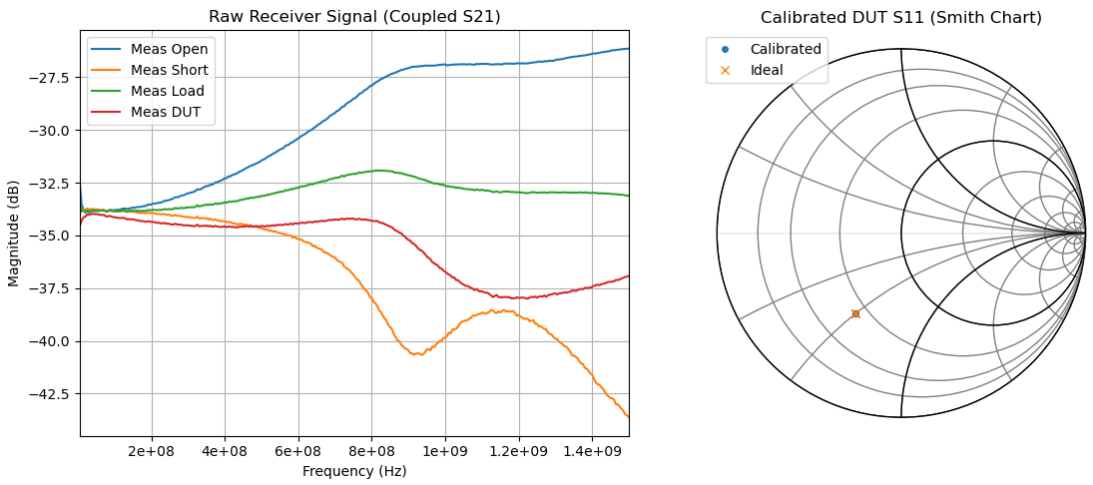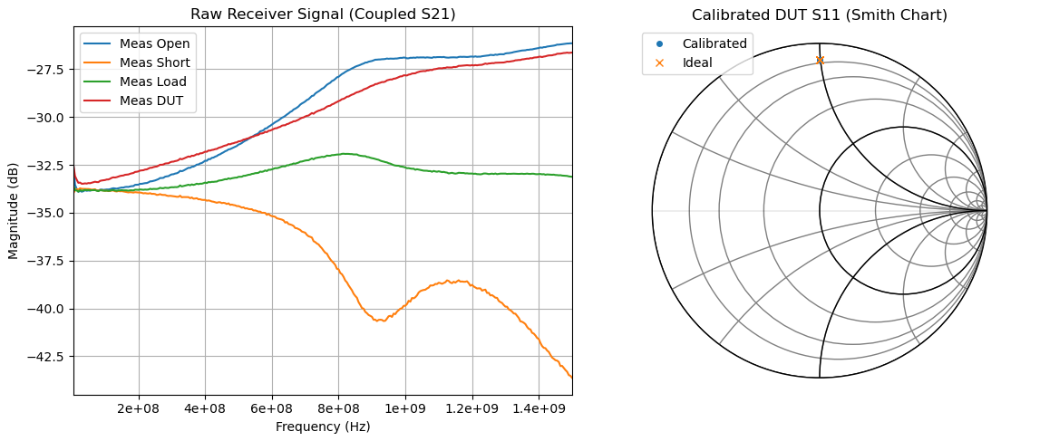
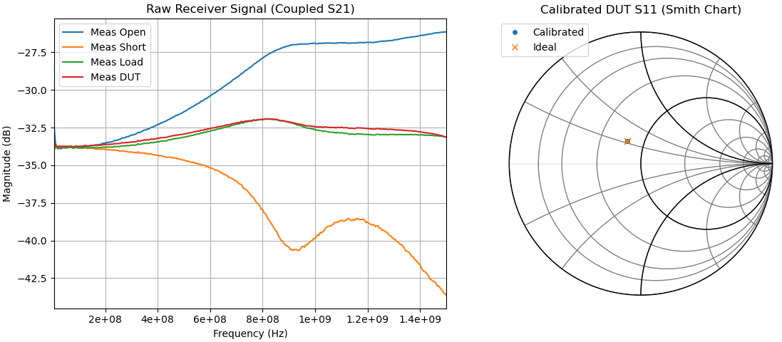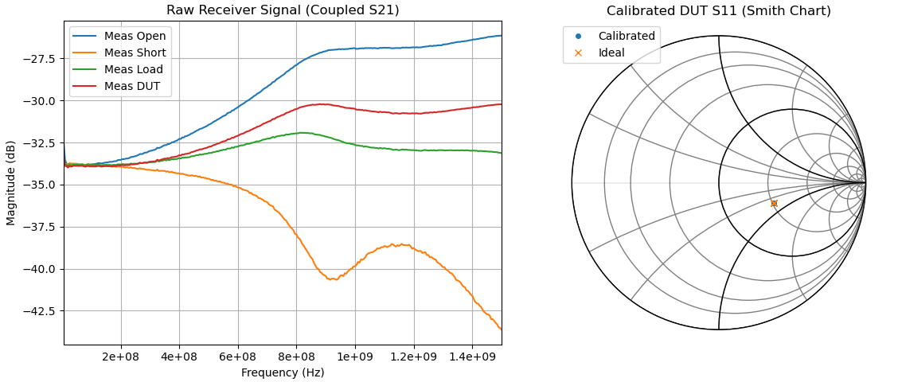
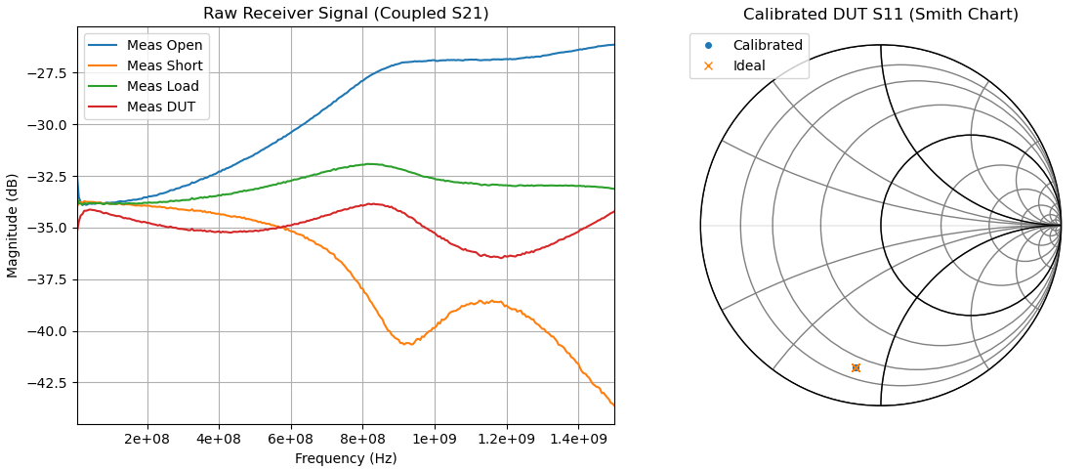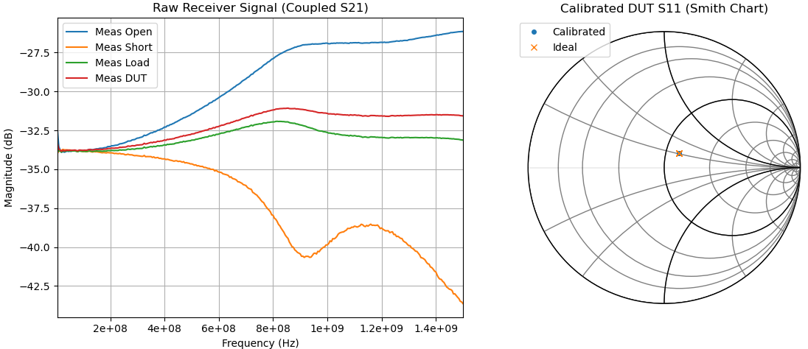
Figure 4. The s-parameter plot of the DUTs and the ideal OSL with the calibrated Smith chart plot of the DUT S11

